**Business Idea:** Pocket Menu

**Group Members:** Gavin Boyle & Conor Ward

|  |  |
| --- | --- |
| **Market Analysis Details** | |
| Description of the Industry | Takeaways, restaurants, gastropubs and cafes are all part of  the food service industry. Reports show that the industry is ever growing with healthier food options ever increasing due to people being more nutritionally concise. We offer low cost advertisement and marketing as well as business information and premium online ordering system. |
| Size of Industry | Bord Bia estimate the industry is worth €7.5 billion in Ireland. Irish consumers spend €1.45 billion on food consumed outside the home from 3,000 different restaurants that employ 25,000 people annually. Report suggests online ordering to increase by 40-60%. |
| Rate of Growth | Report suggests the industry will grow to be worth €9 billion by 2020 and online ordering is to increase 40-60% |
| Potential Growth | The industry is growing at 4.9% annually and will hit €9 billion by  2020. |
| Macroeconomic Drivers | Gross Domestic Product (GDP), Increase in employment more  money to spend on food, report shows people are starting to eat out more rather than eating in the home, Consumer price index, increase in minimum wage and decrease in Consumer price index where food service industries are having a decrease in prices of  products. |
| Other Drivers | Businesses are constantly looking for opportunities to marketing their business. More and more business are looking towards enhancing their web presence. Opportunity to Increasing Revenue. With the Increase in the population increases potential customers |
| Trends in the Industry | * Moving away from printing. Digital Marketing is forever increasing with 90% of the population in Ireland have access to a smartphone. |
| Customer Segment | Older generation restaurant owners/managers would need more convincing as they may not be tech-savvy. Younger restaurant owners/managers would have a better understanding the benefits of utilising technology for marketing. |
| Source Market | Businesses are currently using Facebook, Google, and Twitter as free online marketing. Paid services include developing web pages, applications, or joining ordering service apps. Some businesses are still printing and distributing menu’s do |
| Target Market | Restaurants, take-aways, gastropubs and cafés. |
| Competitors | JustEat (Take-aways) - €750 (+VAT) up front. For every order, Just Eat take 13% (+VAT) PLUS a 50c admin charge.  Marvin.ie (Take-aways) - 7% order fee + unknown set up fee  Flipdish (Personal take-away application) - €1200 set up + 7% of order fee + 2.5% card fee  Deliveroo (Restaurant/Cafes) – 30% commission per order + unknown set up fee |

Graphs



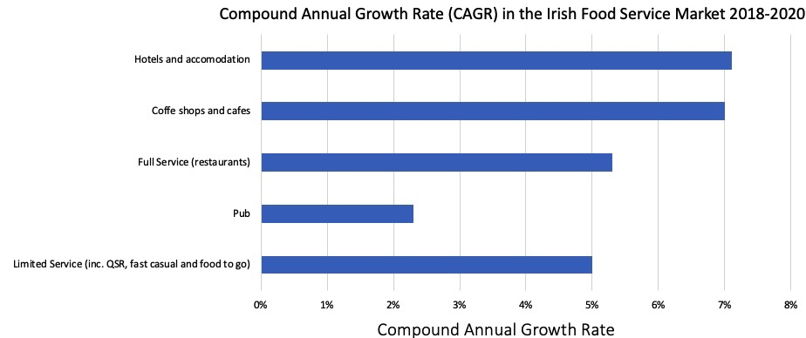

References

<https://www.irishpubsglobal.com/bord-bia-releases-2017-irish-foodservice-channel-insights-report/>

<https://www.cso.ie/en/releasesandpublications/er/lfs/labourforcesurveyquarter22018/>

<https://www.bordbia.ie/industry/events/SpeakerPresentations/2017/IrishFoodserviceDirectory/2017%20Irish%20Foodservice%20Channel%20Insights.pdf>

<https://www.statista.com/statistics/547823/cagr-irish-foodservice-market-by-sector/>